**ST. MARCELINO ACADEMY-MATUGGA**

**HOME STUDY LITERACY WORK TERM III, WEEK I**

**PRIMARY ONE**

**NAME: …………………………………………………..…. STREAM: ………**

**WORK FOR MONDAY 22ND TO FRIDAY 26TH NOVEMBER, 2021:**

**LESSON INFORMATION:**

**LESSON ONE:**

**THEME: WEATHER**

* Weather is the condition of the atmosphere at a given time

**Elements of weather**

* Elements or factors of weather are things which cause or bring changes in weather.
* They are also called weather makers.

**Elements of weather include the following:**

* wind
* sunshine
* rainfall
* cloud cover

**Diagrams showing the elements of weather:**

* Rainfall

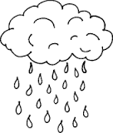

* cloud cover

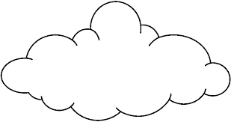

* sunshine

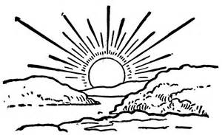

* wind

**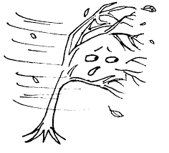**

**Exercise**

1. Fill in the missing letters

w\_\_\_ath\_\_\_r

r\_\_\_infall

w\_\_\_nd

cl\_\_ \_\_d c\_\_ver

1. **Name the elements of weather drawn below.**

|  |  |  |
| --- | --- | --- |
| C:\Users\BABA STEVE\Desktop\BABA DIAGRAMS AND PICTURES\EVE NPPS PHOTOS\rain droplets.png | C:\Users\BABA STEVE\Desktop\BABA DIAGRAMS AND PICTURES\EVE NPPS PHOTOS\sun rising.jpg | C:\Users\BABA STEVE\Desktop\BABA DIAGRAMS AND PICTURES\EVE NPPS PHOTOS\clouds.png |
| \_\_\_\_\_\_\_\_\_\_\_\_\_\_\_\_ | \_\_\_\_\_\_\_\_\_\_\_\_\_\_\_\_\_\_\_\_\_ | \_\_\_\_\_\_\_\_\_\_\_\_\_\_\_\_\_\_\_ |

1. ……………………………………………………………………………..is the condition of the atmosphere at a given time. **(rain, weather, climate)**
2. Name any two weather makers.

i……………………………………………………………………. ii………………………………………………………………..

1. **Draw these elements of weather.**

|  |  |  |
| --- | --- | --- |
| **rainfall** | **cloud cover** | **sunshine** |
|  |  |  |

1. **Underline the elements of weather**

Moon , sunshine , clouds , cloud cover , rain , rainfall , wind , stars , sun

1. Match the following elements of weather correctly.

Rainfall 

Cloud cover 

Wind 

Sunshine 

**Types of weather**

There are four types of weather that are brought by the available elements

* Rainfall – rainy weather
* Sunshine – sunny weather
* wind – windy weather
* Cloud cover – cloudy weather

**The types of weather are these ones below.**

* rainy weather
* sunny weather
* windy weather
* cloudy weather

**Note:**

* **The diagrams below show the four types of weather.**

|  |  |
| --- | --- |
| **Rainy weather** | **Sunny weather** |
| **C:\Users\BABA STEVE\Desktop\BABA DIAGRAMS AND PICTURES\EVE NPPS PHOTOS\rainy whether.png** | **[http://ts3.mm.bing.net/th?id=HN.608002640164553215&w=160&h=149&c=7&rs=1&pid=1.7](http://www.bing.com/images/search?q=diagram+of+sunshine&qs=n&form=QBIR&pq=diagram+of+sunshine&sc=0-14&sp=-1&sk=#view=detail&id=C5F1A506BFDB7D69F73D6566F2B6C99E856AFBCA&selectedIndex=141)** |
| **Windy weather** | **Cloudy weather** |
|  | **https://encrypted-tbn0.gstatic.com/images?q=tbn:ANd9GcRhKdhQzoGZmyiZH6lcjvZz-5rSbKI260gzURjd8kUlvxcmShsNIhuIWJwl** |

**Exercise**

1. Name the four types of weather.

i……………………………….………………………………… ii………………………………………………………………….

iii………………………………………………………………. iv…………………………………………………………………

1. Match the types of weather to their elements

Sunny rainfall

Windy wind

Rainy cloud cover

Cloudy sunshine

1. Draw these types of weather

|  |  |
| --- | --- |
| rainy | Cloudy |
|  |  |
| windy | sunny |
|  |  |

1. Name the types of weather brought by these elements.
2. Sunshine
3. Cloud cover
4. Wind
5. Rainfall
6. Identify the types of weather drown below.

|  |  |
| --- | --- |
|  |  |
| \_\_\_\_\_\_\_\_\_\_\_\_\_\_\_\_\_\_\_\_\_\_\_\_\_\_ | \_\_\_\_\_\_\_\_\_\_\_\_\_\_\_\_\_\_\_\_\_\_\_\_\_\_\_ |
| [https://encrypted-tbn3.gstatic.com/images?q=tbn:ANd9GcTSJEyCox_WaQwjEIjQoNg_k6kUnlPWyyyCl1Yk0H-MWm7Okf4cUSUa1OI3](https://www.google.com/search?biw=1366&bih=628&tbm=isch&q=sun+drawing&revid=863788182)[http://ts2.mm.bing.net/th?id=HN.608055837893921360&w=174&h=181&c=7&rs=1&qlt=90&o=4&pid=1.7](http://www.bing.com/images/search?q=%20a%20girl%20holding%20an%20umbrella%20(black%20and%20white&qs=n&form=QBIRMH&pq=a%20girl%20holding%20an%20umbrella%20(black%20and%20white&sc=0-0&sp=-1&sk=#view=detail&id=71675341F85B242CC5B2FD4CE554C709DA6AE8E7&selectedIndex=7) | C:\Users\BABA STEVE\Desktop\BABA DIAGRAMS AND PICTURES\EVE NPPS PHOTOS\clouds.png |
| \_\_\_\_\_\_\_\_\_\_\_\_\_\_\_\_\_\_\_\_\_\_\_\_\_\_ | \_\_\_\_\_\_\_\_\_\_\_\_\_\_\_\_\_\_\_\_\_\_\_\_\_\_\_\_ |

**LESSON TWO:**

**LESSON INFORMATION:**

**Clouds**

**Types of clouds**

1. **Cirrus** **clouds** – These are the highest clouds in the sky.
2. **Stratus clouds** – These are grey in colour. They usually indicate dull or wet weather and may lead to a drizzle.
3. **Cumulus** **clouds** – They look like cotton wool.
4. **Nimbus** **clouds** – They are very dark clouds that bring rainfall.

**Exercise**

1. Fill in the missing letters.

nimb\_\_\_s c\_\_\_rrus str\_\_\_t\_\_\_s c\_\_\_mul\_\_\_s

1. State any three types of clouds.

i…………………………………………………………………… ii…………………………………………………………………

iii…………………………………………………………………………

1. What name is given to clouds that provide rain? …………………………………………………………………………………………………………………………………………….
2. Name the highest clouds in the sky.

…………………………………………………………………………………………………………………………………………….

1. Match the following correctly.

Cirrus clouds give us rain

Cumulus clouds highest clouds in the sky

Nimbus clouds look like cotton wool

**Uses of clouds**

Clouds are very useful to us, they do the following.

* Clouds give us rain.
* Clouds protect us from direct sun rays.

**Dangers of clouds**

Clouds are sometimes dangerous to people.

* Clouds cause thunder
* They cause lightning

**Exercise**

1. Fill in the missing letters.

r\_\_\_in th\_\_\_nder li\_\_\_htn\_\_\_ng

1. State one use of clouds to people. **(Clouds give people food, clouds give people rain)**

……………………………………………………………………………………………………………………………………………

1. How are clouds dangerous to man? **(clouds give people rain, clouds cause lightning and thunder)**

……………………………………………………………………………………………………………………………………………

1. Study the picture and answer the questions.



1. Name the element of weather shown above.

………………………………………………………………………………………………………………………………………

1. Which type of clouds is in the picture?

………………………………………………………………………………………………………………………………………

1. How are the above clouds useful to a crop farmer?

………………………………………………………………………………………………………………………………………

**LESSON THREE:**

**LESSON INFORMATION:**

**Rainy weather**

* Rain is the main natural source of water

**Importance of the rainy weather**

* The rainy weather provides rain

**Uses of rain**

* Rain helps plants to grow well
* Rain provides us with water
* Rain softens the soil for digging

**Uses of water to people:**

* We use water for cooking food.
* We use water for watering plants.
* We drink water.
* We use water for washing clothes.
* We use water for bathing.
* We use water for mopping.
* We use water for washing utensils.

**Exercise**

1. What is the main natural source of water? **(sun, lake, rain, rainfall)**

…………………………………………………………………………………………………………………………………………..

1. Give any one importance of the rainy weather.

…………………………………………………………………………………………………………………………………………..

1. Mention any two uses of water to people.

i………………………………………………………………………………………………………………………………………….

ii…………………………………………………………………………………………………………………………………………

1. Write **true** or **false.**
2. Rain waters plants. ……………………………………………….
3. Rain is the main source of water. ………………………………..
4. Rain dries our clothes. ……………………………………………
5. We use rain water to cook food. …………………………….
6. Rain gives us food. ………………………………………..

**Sources of water**

* These are things that provide us with water.
* Rain is the main source of water in the environment.

**Examples of source of water:**

* Rain
* Lakes
* Rivers
* Swamps
* Springs
* Boreholes
* Wells
* Oceans
* Seas

**Dangers of too much rain**

* Too much rain kills people.
* Too much rain causes floods
* Too much rain destroys plants
* Too much rain spoils roads
* Too much rain causes land slides
* Too much rain kills animals
* Too much rain destroys houses

**Exercise**

1. Fill in the missing letters

­l\_\_ke r\_\_v\_\_r sw\_\_mp w\_\_ll

1. Draw these sources of water

|  |  |  |
| --- | --- | --- |
| Lake | Rain | River |
|  |  |  |

1. Name the main source of water.

………………………………………………………………………………………………………………………………………

1. Circle the sources of water.

**Sun, rain, lake, forest, river, bush, swamp**

1. State two dangers of rainy weather.

i……………………………………………………………………………………………………………………………………………

ii…………………………………………………………………………………………………………………………………………

**Ways of protecting ourselves from rainy weather**

* Using an umbrella
* Taking shelter when it is raining
* Wearing a rain coat
* Wearing gumboots
* Do not play in muddy water
* Do not stand under trees when it is raining

**Materials (things) used to protect ourselves during rainy weather.**

|  |  |
| --- | --- |
| Umbrella | Gumboots |
|  |  |
| Banana leaves | Rain coat |
|  |  |

**Exercise**

1. Give any two ways of protecting against rainy weather.

By ………………………………………………………………………………………………………………………………………

By ………………………………………………………………………………………………………………………………………

1. Draw and name any three materials used during the rainy weather.

|  |  |  |
| --- | --- | --- |
|  |  |  |
| ………………………………………………….. | …………………………………………………. | ……………………………………………….. |

1. **The diagram below shows a girl called Vanessa. Use this picture to answer the questions**

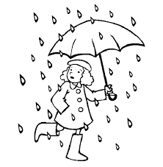

**Vanessa**

1. Name the type of weather shown above.

…………………………………………………………………………………………………………………………………………..

1. What three items is Vanessa using to protect herself during the above type of weather?

i……………………………………………………………………. ii………………………………………………………………

iii………………………………………………………………………

1. Name any one local material Vanessa can use during the rainy weather.

…………………………………………………………………………………………………………………………………………..

1. **During which two types of weather can a P.1 child use the item below?**

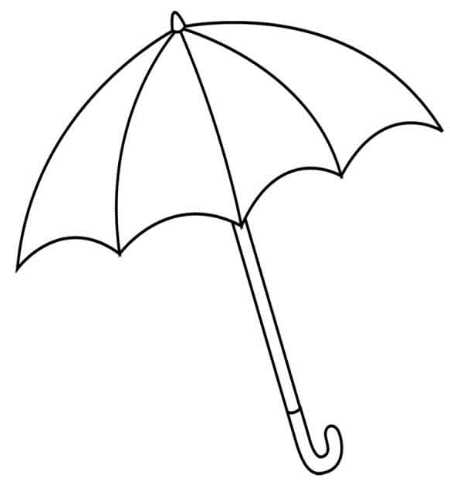

i…………………………………………………………………… ii…………………………………………………………………….

1. When do we carry an umbrella and gumboots?

………………………………………………………………………………………………………………………………………………….

1. **Draw a girl putting on gumboots and carrying and umbrella.**

**LESSON FOUR:**

**LESSON INFORMATION:**

**Windy weather**

* Wind is moving air.

**Uses of wind**

* Wind is used to fly kites.
* Wind is used to fly paper planes.
* Wind is used for winnowing.
* Wind is used to sail boats.
* Wind dries our clothes at night.

**Dangers of windy weather**

* Strong wind destroys houses.
* Strong wind destroys our crops.
* Strong wind causes accidents on lakes.
* Strong wind causes soil erosion.
* Strong wind raises dust.

**Note:**

* **Soil erosion**: is the taking away of top soil.

**Exercise**

1. What is wind?

…………………………………………………………………………………………………………………………………………………

1. Give any two uses of wind.
2. Wind is used to ……………………………………………………………………………………………………………….
3. Wind is used to ……………………………………………………………………………………………………………….
4. What do we call air in motion? **(water, wind, food)**

………………………………………………………………………………………………………………………………………………….

1. How is wind useful at night**? (Wind gives us water at night, Wind dries clothes at night)**

………………………………………………………………………………………………………………………………………………….

1. **Draw these uses of wind.**

|  |  |
| --- | --- |
| Wind is used to fly kites. | Wind is used to sail boats |
|  |  |

1. Give any two dangers of wind to people.

i…………………………………………………………………………………………………………………………………………………

1. What is soil erosion?

………………………………………………………………………………………………………………………………………………….

**Ways of protecting ourselves during windy weather**

* By wearing heavy clothes.
* By planting trees.
* Planting grass in the compound

**Things (materials) used on a windy day**

|  |  |  |
| --- | --- | --- |
| Sweater | socks | gloves |
| **C:\Users\ST.MARCELINO 1\Desktop\CLOTHES\image_downloader_1637351406391.jpg** | **C:\Users\ST.MARCELINO 1\Desktop\CLOTHES\image_downloader_1637351624388.jpg** |  |
| scarf | coat | jacket |
| **C:\Users\ST.MARCELINO 1\Desktop\CLOTHES\image_downloader_1637351499644.jpg** | **C:\Users\ST.MARCELINO 1\Desktop\CLOTHES\image_downloader_1637351890711.jpg** | **C:\Users\ST.MARCELINO 1\Desktop\CLOTHES\image_downloader_1637351800091.jpg** |

**Exercise**

1. State any one way of protecting ourselves during windy weather.

…………………………………………………………………………………………………………………………………………………

1. Circle the items used on a windy day.

**Gumboots, sweater, sandals, gloves, scarves, coat, sunglasses**

1. Draw and name two items used on a windy day.

|  |  |
| --- | --- |
|  |  |
| ………………………………………………………………… | ………………………………………………………………… |

**LESSON FIVE:**

**LESSON INFORMATION:**

**Sunny weather**

* Sun is the main source of light and heat

**Uses of sun**

* The sun gives us light.
* The sun gives heat which dries clothes.
* The sun dries heat which dries seeds.
* The sun provides heat for making solar electricity.
* The sun provides sun light for plants to make food.

**Other sources of light are:**

* Stars
* Bulbs
* Lamps
* Candles
* Torches
* Fire
* glow worm
* fire fly

**Exercise**

1. ………………………………………………………………. is the main source of light and heat
2. Give any three uses of sun. **(The sun gives us food, The sun gives us light, The sun gives us water, The sun gives us heat which dries our clothes)**

i………………………………………………………………………………………………………………………………………………..

ii……………………………………………………………………………………………………………………………………………….

1. The sun provides ………………………………………………………………….. for plants to make food. **( water, sunlight, light)**
2. **Name these sources of light.**

|  |  |  |
| --- | --- | --- |
|  |  |  |
|  |  |  |
|  |  |
|  |  |

**Dangers of sunny weather**

* Too much sunshine dries our crops.
* Too much sunshine dries water sources
* Too much sunshine makes us thirsty
* Too much sunshine kills animals

**Ways of protecting ourselves from sunny weather**

* Wearing light clothes
* Using an umbrella
* Wearing sun glasses
* Sitting under a shade
* Wearing white clothes
* Drinking a lot of water

**Items used on a sunny day**

|  |  |  |  |  |
| --- | --- | --- | --- | --- |
| **Sun glasses** | | **vests** | **hat** | |
|  | |  |  | |
|  | | |
| **umbrella** | |

**Exercise**

1. Name the main natural source of light.

……………………………………………………………………………………………………………………………………………………

1. Mention two dangers of too much sunshine.

i………………………………………………………………………………………………………………………………………………….

ii…………………………………………………………………………………………………………………………………………………

1. **Draw and name any two sources of light created by God.**

|  |  |
| --- | --- |
|  |  |
|  |  |

1. **Use the item below to answer questions that follow:**

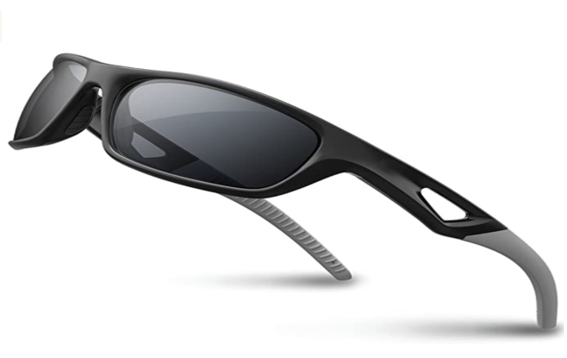

1. Name the object drawn above.

……………………………………………………………………………………………………………………………………………

1. During which type of weather can a P.1 child wear the above object?

……………………………………………………………………………………………………………………………………………..

|  |  |
| --- | --- |
| **Parent`s comment:** | …………………………………………………………………………………………………… |
| **Signature:** | …………………………………………………………………………………………………… |
| Contact: |  |